# Field report: How do Kenyan Farmers respond to drought?

# Updated 30th November 2017

Jonathan Stern, PhD candidate in Economics,

University of Sussex

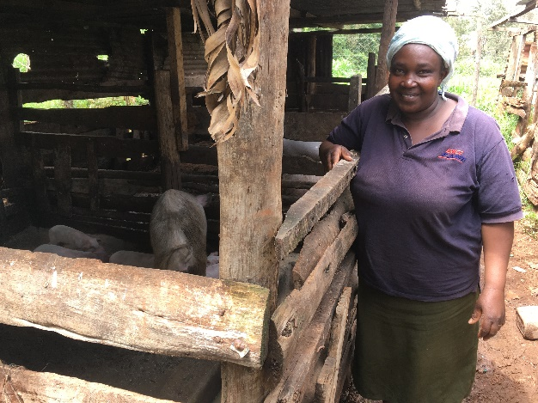

Contents

Field report: Kenya November 2017 1

Introduction 1

Farmer and farm Characteristics 1

Weather information 2

Effect of drought 3

Adaptation 3

Social learning 4

Wellbeing 5

Discussion: implications for field studies 5

References 7

Annex 1: (Table 1) Farmer/ farm characteristics 8

Annex 2: Images 9

Interview transcripts 11

## Introduction and summary

This report presents findings from 8 semi-structured interviews carried out with Kenyan farmers in November 2017. The objective of the interviews was to understand how farmers were affected by drought, coping responses and adaptation measures which they were aware of or experimenting with. This work is for the purposes of scoping and ground trothing, aiming to inform further fieldwork in Kenya in early 2018.

Interviews were conducted in two rural and largely agricultural locations: the first day (November 10th) in Machakos, around 90 minutes’ drive south of Nairobi and the second in Gikambura, around a one hour drive west (November 11th).

Key factual/ descriptive findings from the research were:

* Small scale farmers relying on crops for subsistence were much more severely affected by the 2017 drought than larger scale ones; in many cases they were forced to restrict their meal intake while those on larger farms merely put off long run investments.
* Farmers are already taking a range of measures they considered made them more resilient to shocks; the most prevalent being off farm income and livestock rearing.
* Use of drought resilient maize is widespread; however when purchasing the most prevalent variety (Duma 43) most farmers are not registering for the free insurance that is bundled with it. The reasons for this are unclear.

The interviews raise a number of challenges to the idea that cognitive load[1] is a driver of low risk management. Most importantly, farmers have substantial amounts of free time in the afternoon in which they report relaxing and having more time to think about farming decisions (although this may be the effect of underemployment). In addition after a full interview of talking about weather and drought, many reported low worry scores, where we might expect them to have been ‘primed’ to higher levels of worry. However there are certainly some factors worthy of further investigation arising from this work: in particular why farmers do not register for free insurance, and why farmers purchase fertiliser just before use when prices are highest?

References to specific interviews are coded in the following format: (Day.Interview number). Thus (2.1) would indicate the first interview on the second day.

## Farmer and farm Characteristics

The prevailing ethnicity in Machakos is Kamba and Kikuyu in Gikambura. We interviewed farmers with a wide range of asset bases, all of whom had experienced a shortfall in rain. All but one farmer owned their land (2.2). The largest farm was over 100 acres (1.1) and the smallest around half an acre (2.1, 2.4). The farmers with over 10 acres were also in all cases educated to at least undergraduate degree level and in one case masters’ level (1.2). Table 1 in the annex summarises farmers´ education, farm size, crops, livestock and other income.

The smallest farms (under 2 acres) which we interviewed were all in Gikambura, (2.1-2.4).These farms were growing crops for own consumption rather than sale, using livestock and off farm labour (including in most cases a husband working) to provide income (1.4- 2.4). They were generally educated to secondary (1.4, 2.1) or primary school level (2.3, 2.4).

During the first day of interviews we began asking about farm inputs such as fertiliser and improved seed and we found they were widely used even on the smallest farms, and in some cases were being provided subsidised (1.3) or free (2.1). The purchase time of these inputs varied from ‘just in time’ (2.3) to one month before use (2.4). Generally it was felt that these inputs could be purchased more cheaply if buying well before planting time; only in one case did the farmer report that the purchase time would make no difference to the price (2.2). In one case purchasing early was reported as a commitment strategy, to ensure that they were purchased before funds got used on other things (2.4).

We also asked about a typical day to get a sense of when the busy times were. It became apparent that for every farmer asked (1.4 -2.4 inclusive), work was done in the morning and afternoons were spent resting at home. When we probed one farmer (2.1) about why they did not do more work in the afternoon given the economic hardship which she had described she said that she was not aware of options to gain more income. This was surprising given that she was already selling tea leaves at a Nairobi hotel and had a successful pig rearing business.

Nearly all farmers reported being busiest at planting and harvest times. These followed the short rains (October- February) and Long rains (March/April- August-September) cycle. Unfortunately we did not think to ask if during this time the length of workday increased from a half day to a full days´ work, although Donnah Kigan at Busara later confirmed that she believed this to be the case. For one farmer working as a teacher (1.3) school term also dictated buys/ stressful times (January-March, May-July, September- October). For another farmer struggling to pay the fees for her own children the start of school terms when payment was due created stress (2.1).

## Weather information

Radio and TV were the most common channels to receive weather information, although they were widely mistrusted, with previous inaccuracy cited as a reason for not trusting the meteorological forecast (1.2). Another respondent simply stated that the radio forecast was “not at heart (1.4).” In Machakos it was widely practiced to predict the short rains by observing the shedding of leaves, hot sunny weather and flowering of certain trees (1.1, 1.3, 1.4).

During the second day in the field we modified questions to gain some information about the weather forecast before the long rains and how this affected the mental state of participants. The two farmers we asked about this were very worried when they heard the forecast of drought, but took no action. One had already purchased non drought tolerant seed and so was reluctant to switch having already invested (2.4). For the other it was not apparent why they did not take any mitigating action upon learning of the forecast (2.3), although we can speculate from her mixed attitude to the reliability of weather forecasts that mistrust of the forecast may have been a factor. We also heard from one farmer (1.2) that the forecast before the last long rains had been for little rain but it had turned out ok, so the fallibility of forecasts may have been salient.

“Last season but one little rain was predicted but in fact it was normal. So now we just plant and hope God will provide (1.2)”.

There was also some mention of possible climate change: “*The seasons are changing: you can’t predict (1.2)”.* We did not explore this issue further, but this of course could affect how farmers seek to interact with weather information in the future.

## Effect of drought

The severe drought occurring in the long rains of 2017 affected the harvest of all farmers interviewed. Harvest losses reported ranged between 65% and 100% in Gikambura and 50% to 65% in Machakos relative to a normal year. However some of the larger farms reported little or no effect on their standard of living. These farmers in many cases had professional jobs providing additional income, but also were still able to harvest some crops which then sold at a higher price (1.1). For those larger farmers that reported a negative effect, this was limited to putting off long run renovations and reduction in profit (1.2) and in one case weakening and death of oxen (1.3).

For the smaller farmers the drought heavily reduced or eliminated the modest harvests that they usually rely on for own consumption. In order to buy food they were forced to sell livestock, in one case before they matured (2.1). In order to cope smaller farmers were involved in micro-enterprise such as selling tea leaves (2.1), relying on credit from social organisations (2.1), and the charity of friends, neighbours and relatives (2.1, 2.2, 2.3). In a number of cases meal portion sizes had to be reduced (1.4, 2.1) or the number of meals reduced to one per day (2.3, 2.4).

## Adaptation

Before prompting, most farmers reported at least one option they were aware of to reduce the impact of droughts on them in the future. Amongst larger farmers, some were already practicing rainwater harvesting for agricultural use (1.3), and accessing a well (1.1). These options were considered unavailable or too expensive by smaller farmers, but most farmers relied heavily on other/ off farm income as a risk diversification strategy. One farmer was also practicing post-harvest preservation/ treatment in order to preserve stocks (1.4) and another had grown cassava and yams which require little water and can provide subsistence (2.4). Others were considering becoming crop traders (2.1), looking for jobs or business ideas (2.2) or purchasing livestock “goats are drought resistant… poultry has no problem” (1.1, 2.4).

Upon prompting, it became clear that drought tolerant (DT) maize was widely heard of and used. Farmers heard about it through TV and radio (1.2), but also through extension agents (1.3) support networks (1.4) and agrovets (2.4). Experience was mixed with some good experiences with strong yield (1.2, 2.2) and some negative ones. A farmer who did not use fertiliser obtained poor yield with a drought tolerant variety (1.4). Another farmer stated poor/ no yield but it is not apparent why (1.1). One farmer also cited a known issue in Kenya of counterfeit seeds (1.3) and another said that the DT varieties were not currently available (1.1), in contrast to the experience of the others.

By far the most commonly reported DT variety used was the Duma variety studied by Busara in a recent field trial[2], and the experience is particularly interesting. Widely planted (1.2,1.3, 1.4, 2.3) but in all but one case (1.3) the farmer threw away the leaflet without registering the product so would not benefit from the insurance they had already paid for by purchasing the product. On the occasion where we probed this it was apparent that the farmer did not understand that insurance was offered with the product, despite the product having been the subject of a behavioural economics-inspired trial to explore ways to improve registration rates.

No farmers had heard of crop insurance aside from the Duma variety, and most did not recognise this as crop insurance, but rather another drought tolerant variety.

## Social learning

Many farmers reported learning from other farmers and the presence of experimental farmers who other farmers would visit in order to pick up new techniques (1.1, 1.4, 2.1, 2.4). A number of farmers reported being a part of or wishing to join social groups which were visited by agricultural extension officers. Social groups were also a target for agricultural extension officers, with farmers reporting advisory visits to their local farmers’ (1.4), womens’ (1.3) and church groups (2.1, 2.2).

“There are some farmers who are more advanced around this place, especially those just doing farming itself. You can go and research with them. Some are growing bananas. Across there [points] there is someone is who is growing mangos. He has bought a piece of land. Has grown vegetables. Only using a well. I have a well here but have not done that. So I went to enquire from him what he has done. I got some information and encouragement.” (1.1)

## Wellbeing

Participants were generally able to answer our subjective wellbeing and worry questions where they were asked to rate their happiness and level of worry ´these days´ on a scale of 0-10. The mean happiness score reported was 6.3 with a range from 5 to 8 out of 10. Worry scores varied a lot from zero out of ten (no worries at all) to seven, with a mean of 3.7. Although differences are of course not statistically significant due to sample size, it is perhaps interesting that mean worry scores were higher for smaller (and less resilient?) farmers (4.4) than large farmers (2.0) and happiness scores lower (6.0 against 6.7). A reason given for low worries and high happiness was religious faith (1.2).

Farmers reported being relaxed and more able to think about farming and future decisions in the afternoon (2.1, 2.4) and at night (2.3).

## Discussion: implications for field studies

The findings present a mixed picture to the idea that ‘cognitive load’ in the sense described by Mullainathan and Shafir (2013) is driving low levels of risk management amongst farmers. Given the challenges the farmers face in coping with the food scarcity brought about by drought (including restricted meals) and lack of employment options it seems likely that cognitive load will be experienced. It is apparent that for much of the year, farmers are either under-employed or enjoying substantial leisure time with afternoons spent relaxing at home. Fitting this, many farmers reported that afternoons and evening is when they are more relaxed and have time to consider farming decisions (1.4, 2.2, 2.3, 2.4). However subsequent conversation with Busara suggest that at harvest and planting time the day is extended, fitting with the idea that these are times of high cognitive load. Unfortunately, conversation with Jesse Flanagan who runs experimental trials at the One Acre Foundation in Kenya suggest that a time-of-day based intervention (ie sending SMS at particular times to see if farmer response varies with cognitive load) will be challenging given large delays (around three hours) in SMS delivery in rural Kenya. .

It is noticeable that after talking to us about droughts and their impact for 45 minutes or more, most farmers in our sample reported quite low worry scores, not higher than five out of ten. If cognitive load can be primed by talking about the weather, we might expect our interviewees to report high worry scores (as per Lichand and Mani, 2017). Note by contrast a farmer grieving a recent family loss reported the highest worry score (7); evidence that the metric picks up something relevant to the farmers’ emotional reality.

Another barrier to risk management indicated in the farmers´ comments is the idea that the farmers have a somewhat fatalistic worldview, with bad weather and harvest performance, as well as happiness or otherwise attributed to ´God´s will´ (2.2).

“Last season but one little rain was predicted but in fact it was normal. So now we just plant and hope God will provide.” (2.2)

It is interesting to speculate about why farmers did not take up the free insurance offered with the Duma 43 product. Our limited evidence suggests they did not read or understand the leaflet packaged with the product encouraging them to register for the free insurance by SMS, and/or were not informed by sales staff/ packaging about it. It could have also been the case that they were focussed on preparing for and carrying out planting and registering for the insurance fell ‘outside of their tunnel’ (Mullainathan and Shafir, 2013). This suggests potential for a ‘nudge’ whereby farmers are auto-enrolled in the crop insurance, perhaps by registering the phone number used to make payment for the insurance at purchase time (assuming payment by MPESA SMS transfer). However, in discussion with Ruth Canarajah at Busara after this fieldwork took place, I learned that the registering of the insurance has to take place on farm as the location that the SMS is sent from is used as the location for determination of rainfall related index insurance payments. Alternatively, timely reminders to register the product might help, although without having registered their number with the company, it is not clear how this would be enacted.

Another interesting set of issues arises around fertiliser and seed purchase. All but one farmer espousing organic principles used these inputs, although one obtained them free (2.1) and another at a subsidised price (1.3). Farmers reported substantial variation of price with inputs most expensive at planting time. Nevertheless a number of farmers chose to buy their inputs at that moment (2.3). Others however chose to purchase a month ahead, with commitment strategy and price given as reasons for this. Following Duflo et al (2011), it would be interesting to explore behavioural issues around the timing of fertiliser and seed purchase- i.e. can farmers be persuaded to purchase seeds and fertiliser early through simple nudges, avoiding higher prices and the risk of low liquidity at planting time.

Interventions of the kind described here would all be likely to require collaboration and buy in from a seed or fertiliser company such as Kenya Seed Company or Acre fund (who produce and market Duma 43). It is unclear if this would be viable for the envisaged study and timeline. Alternatively it may be possible to design a lab in the field type experiment which would test some of the underlying principles of one of the above interventions. For example, farmers could be supplied with weather forecasts and asked to choose crops and inputs on a ‘model farm’, where one of the options would include crop insurance. The ‘default’ crop could be varied from an option including insurance to one without, to explore whether auto-enrolment affects insurance take-up. Cognitive load tests could be incorporated in the game. Similar types of game could be imagined to explore fertiliser/ seed purchase timing decisions.

Finally, the weather/ climate information questions indicate that farmers are generally mistrustful of forecasts, with past inaccuracies weighing heavily in farmers’ minds when considering the decision as to whether/how to adapt. A potential treatment could explore whether different means of transmission of weather/ climate information in the presence of cognitive load would engender greater trust, eg use of agronomists versus radio information, or through varying the style of communication to test existing insights from behavioural economics in a cognitive load context.

## References

Duflo, Kremer and Robinson (2011) “Nudging Farmers to Use Fertilizer: Evidence from Kenya”, *American Economic Review* 101 (6): 2350-2390

Lichand and Mani (2016) “Cognitive droughts” working paper

Mullainathan and Shafir (2013) Scarcity: The true cost of not having enough, Penguin

# Annex 1: (Table 1) Farmer/ farm characteristics

|  |  |  |  |  |  |
| --- | --- | --- | --- | --- | --- |
| Reference (day.no) | Education | Farm Size (acres) | Crops other than maize and beans | Livestock | Other income |
| 1.1 | Degree | 105 | Cowpea, grass, greens, cassava, pumpkins. | 30 cows | Teacher salary. |
| 1.2 | Masters | 27 | Cowpeas, peas, pigeon peas. Sometimes vegetables, tomatoes, greens. | pigs | Teacher salary, Husband salary, |
| 1.3 | Degree | 10 | Peas, veg. | None mentioned | Professional teacher (around 60% income). |
| 1.4 | Secondary | 3.5 | Peas, cowpea, pigeon pea | 15 cows, 10 goats, 7 sheep and 15 chickens. | None |
| 2.1 | Secondary | 0.5 | Potatoes, spinach, kale. | 15 rabbits, 18 pigs | Tea leaves, husband salary as driver |
| 2.2 | College | 1.5 | Potatoes | pigs | Husband earnings as businessman (normally but not working now due to injury) |
| 2.3 | Primary | 1.0 | Potatoes, napier grass (animal feed). | None mentioned | Casual labour income, selling timber |
| 2.4 | Primary | 0.5 | Potatoes. cassavas and yams | None right now- used to have but sold to pay hospital bill | None mentioned right now |

# Annex 2: Images

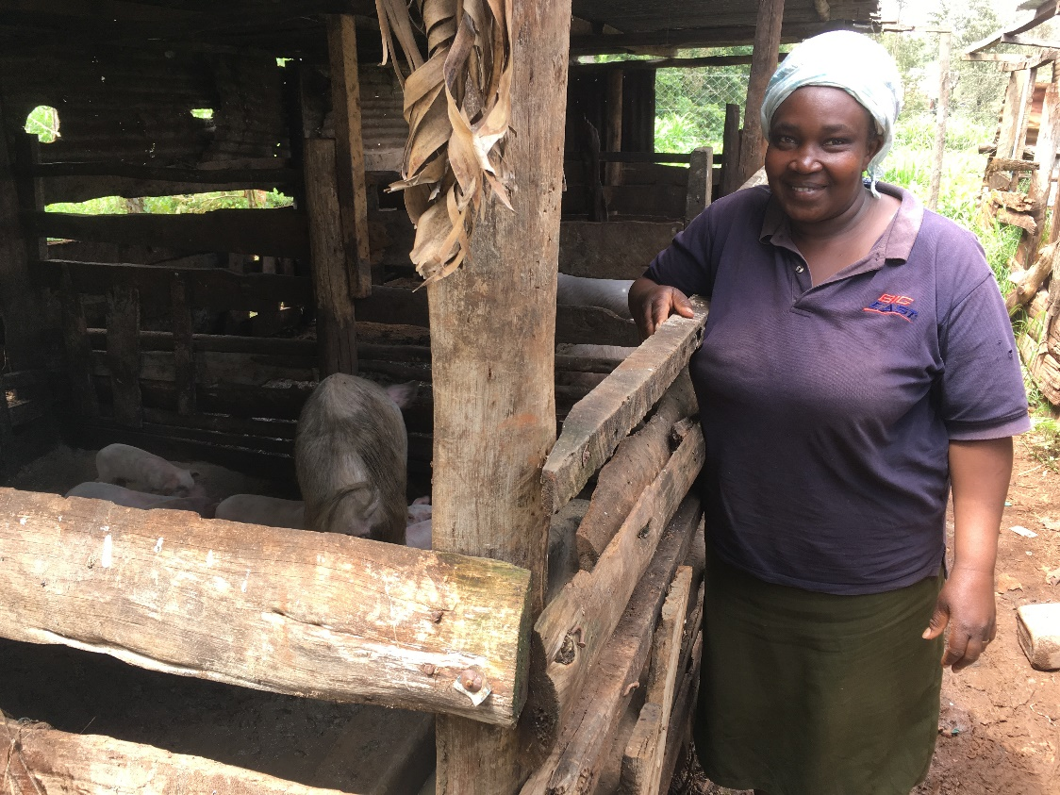

Figure 1: Faith (2.1) relied on selling pigs and tea leaves to get her through the drought of 2017

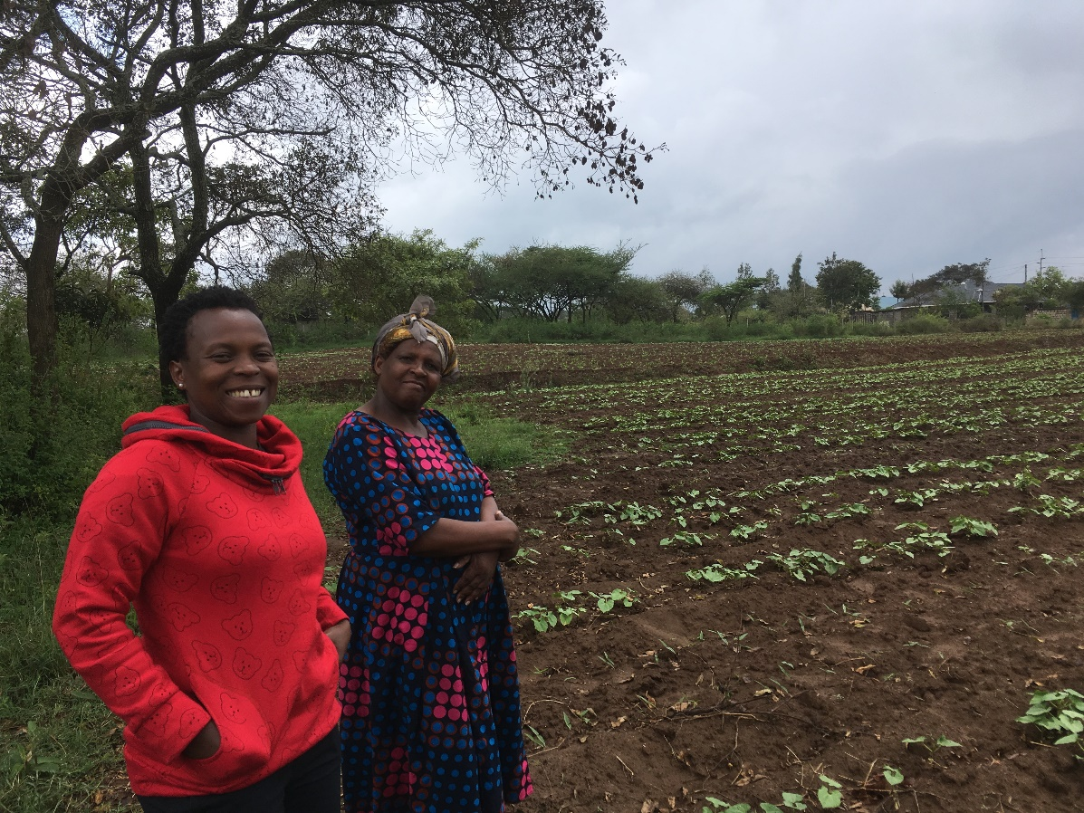

Figure 2: Regina (respondent 1.1, right) reported having "zero worries". She possessed the largest farm in the sample, and benefited from price rises in selling her crops in 2017.

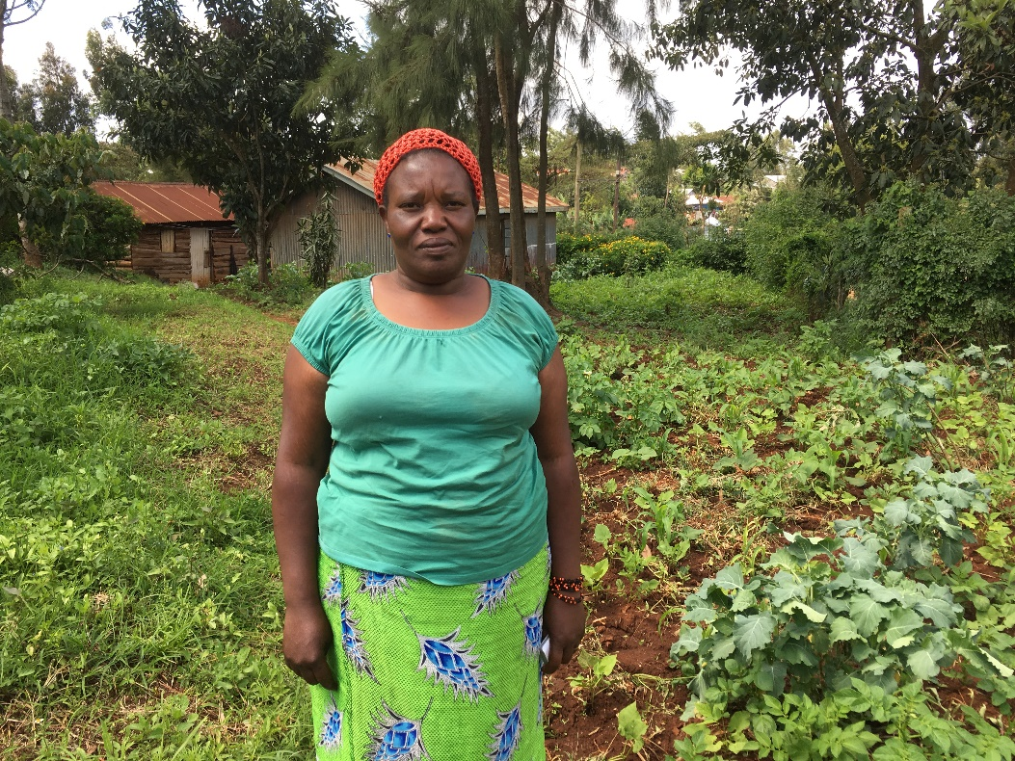

Figure 3: Lucy (2.3) said she would take up free crop insurance if offered; however she did not register her Duma 43 seeds.

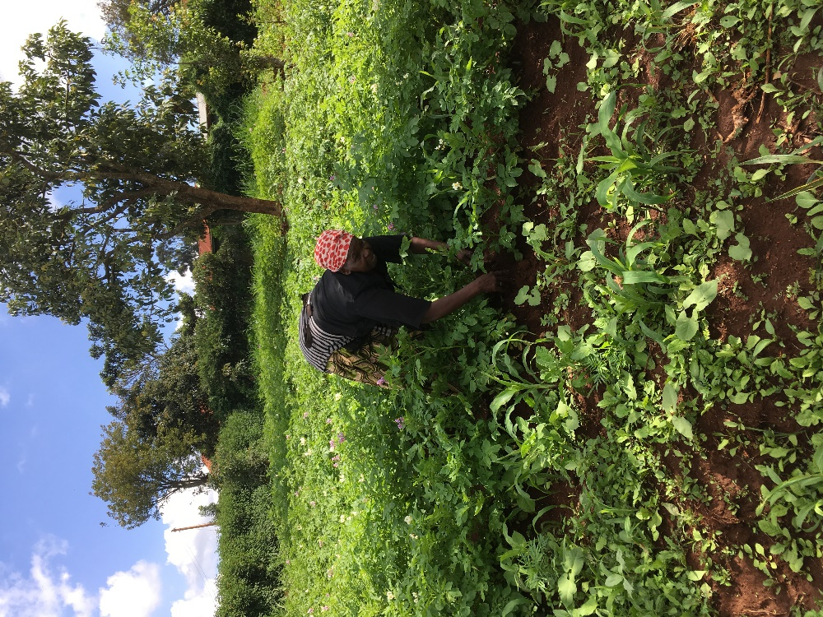

Figure 4: Mary (2.4) wanted to be photographed hard at work with her weeding. She and her husband are considering livestock farming for drought resilience.

# Interview transcripts

## Friday 10th November: Machakos county, Matangulu location, Nguluni village

Senior field officer: Eunice Mutindi. Eunice and Jonathan attended all interviews on this day. Interviews were conducted in a mix of English and local language (Kikamba)

## Interview 1: Regina, 59

**Briefing:** Hello, my name is Jonathan stern, PhD candidate at University of Sussex, UK. This interview is part of a research project on farmers and drought. The interview will take around 30 minutes and the results may be used to inform a published research paper, but individuals will not be identified.

### Background

* Can you tell me about your family? Do you have any brothers, sisters, children etc.

Husband, 8 children all grown up, 5 boys 3 girls.

* Can you tell me the highest level of education you have completed (primary, secondary, university) etc.

Degree in education.

### Farm: Planting, timings

* Is your farm your main source of income? Do you have any other sources?

Yes, more than ¾ of income. She also is a teacher.

* What do you grow on your farm?

Maize, beans, cowpeas, grass (pasture), greens, cassava, pumpkins. Maize and beans are the main crops, although it depends on the market. Beans are the most profitable.

Also has 30 cows.

* How big is your farm (units acres/ hectares)?

42 hectares planted. There is other land also (did not quantify)

* Do you own your farm or is it rented or owned by a relative?

Owns farm.

* When do you decide what to plant in the next growing season? (month/ week)

Decides immediately after this season’s harvest.

* When do you plant? When do you harvest?

Feb=beans, march more beans, cowpeas takes a bit long harvest in August

Pumpkins 2 seasons (harvest march, august).

Harvest grass for animal feed in July

Short rains October- December, Long rains start March/ april.

* When are the busy times for you and when do you have more time to do things? (month/ week, but also times within a typical day).

She plans. Teaches in a day school which gives flexibility. Plan at home. Has people assisting so her job is to manage. However she didn’t even finish planting this season before the rains started two weeks ago.

Busiest time are harvest: July, Aug, September long rains harvests. Feb and March Short rain harvests.

She uses manure at various times, has to be put in August.

### Weather info and perceptions

* How do you get information about the weather which is coming (peers, radio, TV, internet, SMS, extension)?

Mostly media- although don’t mostly rely on this. ‘They somehow alert us’. Good rains were predicted for November which we are seeing. Sometimes the media is wrong.

Sources: Nation newspaper, television. No radio. Do sometimes receive text messages advertising products. ‘We are also African’ – the African way is when certain trees shed their leaves and start flowering we know the rains will be coming. This works for the short rains.

* What information do you get (weather forecast and how often?

Look at newspaper daily. Television when about to plant.

Sometimes agricultural specialists come and share information.

* Which sources are most important to you and why?

‘Weathermen’- TV and newspaper.

* How do you think the rainfall will be this coming long rains? (average, low, drought, high, flood) (can use to assess availability, optimism).

Can’t tell.

* Why do you think the rain will be like this? (prompt if needed)

Not asked.

### Recent drought experience

* Last growing season, were you affected by drought?

Not really. In previous growing seasons, there hasn’t been one she hasn’t harvested “somehow I harvest”. Even in worst droughts the harvest is 40-50%. Maybe farm size helps.

Previous short rains were good: 180 bags of maize. Then 2017 long rains were poor (40 bags). Harvested more beans. But prices also shot up- 5000 Sh [$50, per bag?, making total maize income $2000] was price in LR, but SR it was 2500 Sh [$25- total maize income $4500]. Normally in LR harvests about 80 bags, in good year 100+. 20-25 bags of beans.

* Can you describe the effects of the drought on you, your farm, family and friends?
* What did you do to cope with the drought?

Not asked. [Not apparent that major coping strategies were required, as price partially compensated for lower harvest. Also other crops.]

### Adaptation options and behaviour

* What options are you aware of to reduce the effect which future droughts have on you and your farm (insurance, DT varieties, cash crops, off farm income, support networks available)?

Wants to do less cereals and do more poultry, goats and give shambas to children. “Goats are drought resistant”. Poultry has no problem [with drought].

Harvesting, weeding requires a lot of labour. “Sometimes when you look at what you have harvested and the input you don’t get a lot. The input is very expensive”

When prompted had heard of DT maize. But currently using traditional variety because hybrid is out of stock. Normally Duma 43 which is drought resistant but is v expensive/ not available at the moment. Trad maize matures quickly.

Has heard of crop insurance but never used. “I thought that one was for the large scale farmers in the Rift valley with hectares and hectares of land”.

Last season planted Duma with a tractor and it never yielded.

Does not know about institutions/ farmers assocs.

Are all of these available to you? (which) [list those which are available and ask why some available and others not?]

DT maize not available this season.

* How do/ did you obtain information about these options? (friends, extension, advertising, radio, SMS).

Sharing with other farmers mostly.

* Thinking about the options to reduce drought effects, which if any of the options have you tried? How effective do you think these options were? Why did you choose these options and not others?
* When do you decide whether to take up any insurance (if you consider this?).

N/A

### Social behaviour

* Are there particular farmers in your community who others go to for advice about farming? Can you tell me who they are?

Regina provides information to other farmers about cowpeas.

Some farmers are willing to share information.

* Are there farmers who other farmers look to as experimenters with new technology?

“There are some farmers who are more advanced around this place, especially those just doing farming itself. You can go and research with them. Some are growing bananas. Across there [points] there is someone is who is growing mangos. He has bought a piece of land. Has grown vegetables. Only using a well. I have a well here but have not done that. So I went to enquire from him what he has done. I got some information and encouragement.”

Right now he is selling to us tomatoes and onion. His farm is very small but he has managed it!

### Wellbeing and openness to information

* How happy would you say you are these days? (1-10) How worried (1-10)? When you are worried, what are things that you worry about? Same for happiness.

Happy: 8/10. “I think the more I’m growing old the more I am getting happy. I don’t strain at all. I’m quite relaxed when I’m doing my farming. There were times when I strained but now I’m more relaxed”

Worried 0/10 (not worried at all) “I don’t see a thing to worry about”

* At what times of day/ month/ week would you say you are more relaxed and able to think about your farming decisions such as what to plant or whether to purchase fertiliser? [prep for timing question, i.e. option 2]

“I give myself time.” Not answer to question really.

## Interview 2: Lucy Momo, 41

### Background

* Can you tell me about your family? Do you have any brothers, sisters, children etc.

Four children, 17, 3, 13, 7,3. Husband

* Can you tell me the highest level of education you have completed (primary, secondary, university) etc.

Masters degree in Entomology

### Farm: Planting, timings

* Is your farm your main source of income? Do you have any other sources?

No, teaching. Husband businessman. Farm only supplements income.

Good year: farm provides 200,000 Sh [$2000]. Bad year 100,000 Sh [$1000] per year, the two seasons.

Income from salaries: she gets 62,000 Sh [$620 per month] per month before deductions. Husband has bar and butcher. Can’t say exactly but over 40,000 Sh per month [$400/ month].

[these figures imply farm income is 8-14% of their total income of $13,000-$14,000 per year, so this is a relatively high income household in Kenya].

* What do you grow on your farm?

Maize, beans, cowpeas, peas, pigeon peas. Sometimes vegetables, tomatoes, greens. Maize and beans are the major crops.

* How big is your farm (units acres/ hectares)?

12 acres cultivated [5 hectares], 15 acres grass or trees. [6 hectares]. Total land 27 acres, 11 hectares.

* Do you own your farm or is it rented or owned by a relative?

Owns farm

* When do you decide what to plant in the next growing season? (month/ week)

What does well in short season in this area at the moment is maize. Try to rotate, so where we plant maize this season, next season will be beans. “ Although it is called long rains, it is usually somehow short”

RA: in Eastern Kenya it is the other way round: long rains are longer.

They buy the seeds when rain is almost ready. Beans are planted 2-3 varieties almost at rains time.

* When do you plant? When do you harvest?

Some maize was planted just before start of this season, harvest Feb. Plant again in March, harvest in August.

* When are the busy times for you and when do you have more time to do things? (month/ week, but also times within a typical day).

Busy times planting, weeding and harvesting. Casual labourers work for them. They have to supervise them. Weed at least two times each growing season.

Jan/ Feb not too busy, beans almost ripening. December is very tedious.

### Weather info and perceptions

* How do you get information about the weather which is coming (peers, radio, TV, internet, SMS, extension)?

Tv, radio. TV is the main one. Sometimes misleading. Last season but one little rain was predicted but in fact it was normal. So now we just plant and hope God will provide.

No extension officer visits, SMS, internet.

Watches “Shamba shape up”.

* What information do you get (weather forecast and how often?
* Which sources are most important to you and why?

How do you think the rainfall will be this coming long rains? (average, low, drought, high, flood) (can use to assess availability, optimism).

We are hoping it will be good. Last season we harvested very little. The seasons are changing, you can’t predict.

* Why do you think the rain will be like this? (prompt if needed)

### Recent drought experience

* Last growing season, were you affected by drought?

Yes.

Can you describe the effects of the drought on you, your farm, family and friends?

Yield was very little. If you do the costing of planting, weeding and harvesting there was no profit.

* What did you do to cope with the drought?

Did not irrigate, too difficult. No coping strategies. The farm income is used to do renovation projects on the house/ grounds (wall under construction around perimeter).

### Adaptation options and behaviour

* What options are you aware of to reduce the effect which future droughts have on you and your farm (insurance, DT varieties, cash crops, off farm income, support networks available)?

Did not irrigate, too difficult

When prompted, knows about DT maize. Not knowledgeable about cash crops.

Has heard of livestock insurance but not crops.

Plants maize and beans because knows can sell to local people. Not sure how to market cash crops.

* Are all of these available to you? (which) [list those which are available and ask why some available and others not?]

DT maize is available from agro-vets. Info from radio/ TV.

* How do/ did you obtain information about these options? (friends, extension, advertising, radio, SMS).

Doing it individually.

* Thinking about the options to reduce drought effects, which if any of the options have you tried? How effective do you think these options were? Why did you choose these options and not others?

Usually try DK8031. Yield from this is better than local breed. Size of the cob bigger and yield better. Apply fertiliser and manure and you get two cobs.

Have tried other varieties, Duma 43, Duma 41. With Duma it will produce suckers, but this one doesn’t. Have tried Pioneer but it requires more rain.

When do you decide whether to take up any insurance (if you consider this?).

N/A

### Social behaviour

* Are there particular farmers in your community who others go to for advice about farming? Can you tell me who they are?

Not aware of them.

* Are there farmers who other farmers look to as experimenters with new technology?

Around here, I do not know- not visited one.

### Wellbeing and openness to information

* How happy would you say you are these days? (1-10) How worried (1-10)? . When you are worried, what are things that you worry about? Same for happiness.

7/10 for happy. 2-3/10 for worries (OK). Worries I leave to God. I pray daily to release the worries.

* At what times of day/ month/ week would you say you are more relaxed and able to think about your farming decisions such as what to plant or whether to purchase fertiliser? [prep for timing question, ie option 2]

Not asked.

Her question: can you use this survey to connect us to other farmers?

## Interview 3: Anastasia, 57

### Background

* Can you tell me about your family? Do you have any brothers, sisters, children etc.

5 children (3 boys, 2 girls), husband. Has 6 grandchildren.

* Can you tell me the highest level of education you have completed (primary, secondary, university) etc.

Degree in education.

### Farm: Planting, timings

* Is your farm your main source of income? Do you have any other sources?

No, she is a professional teacher. Around 40% of income from farming.

* What do you grow on your farm? Do you have any livestock?
* Maize, beans, peas, veg. Planted on rotation but not intercropping.
* How big is your farm (units acres/ hectares)?

10 acres.

* Do you own your farm or is it rented or owned by a relative?

### Owned

* When do you decide what to plant in the next growing season? (month/ week)
* When do you plant? When do you harvest?
* When are the busy times for you and when do you have more time to do things? (month/ week, but also times within a typical day).

School terms are busy: Jan-March, May-July, Sep-October. January is a busy time as awaiting Feb harvest.

### Weather info and perceptions

* How do you get information about the weather which is coming (peers, radio, TV, internet, SMS, extension)?

Meteorology through TV, radio, newspapers. Also observe tree shedding. Media is most important though.

* What information do you get (weather forecast and how often?

Which sources are most important to you and why?

* How do you think the rainfall will be this coming long rains? (average, low, drought, high, flood) (can use to assess availability, optimism).

Too early to say.

### Recent drought experience

* Last growing season, were you affected by drought?

Yes

* Can you describe the effects of the drought on you, your farm, family and friends? Include details of harvest if possible (bags, prices etc for main crops versus previous/ normal)

Some crops died. Oxen were weak and some died. Not enough water to plant all their vegetables.

* What did you do to cope with the drought?

Didn’t do anything different.

### Adaptation options and behaviour

* What options are you aware of to reduce the effect which future droughts have on you and your farm (possible prompts: insurance, DT varieties, cash crops, off farm income, support networks available)?
* Are all of these available to you? (which) [list those which are available and ask why some available and others not?]
* How do/ did you obtain information about these options? (friends, extension, advertising, radio, SMS).
* Thinking about the options to reduce drought effects, which if any of the options have you tried? How effective do you think these options were? Why did you choose these options and not others?
* When do you decide whether to take up any insurance (if you consider this?).

They harvest rainwater.

Also are seeking access to a local borehole.

They use DT maize- Duma, pioneer, para, others. They say there is a problem with counterfeit seeds.

Have heard of crop insurance- for every three packets of seed they get Duma. They have registered it. Yet to see how effective it is.

They found out about it from their nearby sub-county agricultural office.

No social network for this kind of information.

Also growing chick peas which are drought tolerant and do well in the long rains.

They also cut grass and store it as animal fodder.

### Social behaviour

* Are there particular farmers in your community who others go to for advice about farming? Can you tell me who they are?

Ag extension officers will come to womens’ groups if called. Will advise on drought resilience, fertilisers. Also provide products at subsidised price. However “people are reluctant to listen”.

* Are there farmers who other farmers look to as experimenters with new technology?

There is a govt research centre in Machakos.

### Wellbeing and openness to information

* How happy would you say you are these days? (1-10) How worried (1-10)? . When you are worried, what are things that you worry about? Same for happiness.

Happy 5/10. Worry 4/10. Worries are about family and farm issues, school fees.

* Are there times of day when you have more time to think about farming or other decisions you need to make?

## Interview 4: Leah, 32

### Background

* Can you tell me about your family? Do you have any brothers, sisters, children etc.

1 child, mother, brother and his wife and their four children, sister and her 2 children.

* Can you tell me the highest level of education you have completed (primary, secondary, university) etc.

Form 4 secondary

### Farm: Planting, timings

* Is your farm your main source of income? Do you have any other sources?

Farming is only source.

* What do you grow on your farm? Do you have any livestock?

Maize, beans, peas, cowpea, pigeon pea. Also has 15 cows, 10 goats, 7 sheep and 15 chickens.

* How big is your farm (units acres/ hectares)?

1.5 acres cultivated, 2 not cultivated.

* Do you own your farm or is it rented or owned by a relative?

Own farm.

* What inputs did you use this season and when did you purchase them?

Does not use fertiliser but uses manure. Afraid of the chemicals and the effect on soil quality over time (becoming dry and reliant on more fertiliser). She says those who harvest a lot do use fertiliser.

* When do you decide what to plant in the next growing season? (month/ week)
* When do you plant? When do you harvest?

Plant 1 week before rain starts, by looking at tree leaves, hot sun as signs For short rains. For long rains it is harder.

In January harvest beans, feb maize. Peas harvested in September. Beans harvest June, maize in July.

* When are the busy times for you and when do you have more time to do things? (month/ week, but also times within a typical day).

Busy throughout the year- planting, weeding, harvesting. End Sep is quietest. January not too bad, waiting for beans to be ready.

* Can you describe for me a typical day on your farm during January- (time getting up, what then, activities, meal times etc.)?

Typical day- wake up at 6, milk cow, breakfast before 8, go to nearby farm. Work to 12.30. Have lunch then relax in the afternoon.

### Weather info and perceptions

* How do you get information about the weather which is coming (peers, radio, TV, internet, SMS, extension)?

Radio. No info from other farmers, TV internet, SMS, extension.

Don’t listen much to radio or rely on at it- not “at heart.”

* What information do you get (weather forecast and how often?
* Which sources are most important to you and why?
* How do you think the rainfall will be this coming long rains? (average, low, drought, high, flood) (can use to assess availability, optimism). l)

Optimistic.

* Why do you think the rain will be like this? (prompt if needed)

### Recent drought experience

* Last growing season, were you affected by drought?

Not enough rain, but not really affected.

* Can you describe the effects of the drought on you, your farm, family and friends? Include details of harvest if possible (bags, prices etc. for main crops versus previous/ normal)

Normal harvest 10x 90kg bags maize, 5 bags beans.

Last long rains: 3.5 bags maize, 2.5 bags beans.

* What did you do to cope with the drought?

Planted early. Reduced food portion. Sold chickens, cows. Rely on family in the city.

### Adaptation options and behaviour

* What options are you aware of to reduce the effect which future droughts have on you and your farm (possible prompts: insurance, DT varieties, cash crops, off farm income, support networks available)?

Treat harvest so not affected by bugs.

Not heard of crop insurance.

Heard of DT maize- has planted Duma 43, Kutumani. Learns about from radio, TV, support network.

However prefers indigenous variety which matures quicker. Also says indigenous variety yields better! Neighbours with DT variety harvested nothing!

Member of farmer group. Ag extension officers visit them and give farming information.

* Are all of these available to you? (which) [list those which are available and ask why some available and others not?]
* How do/ did you obtain information about these options? (friends, extension, advertising, radio, SMS).
* Thinking about the options to reduce drought effects, which if any of the options have you tried? How effective do you think these options were? Why did you choose these options and not others?

### Social behaviour

* Are there particular farmers in your community who others go to for advice about farming? Can you tell me who they are?

Knows of farmers who others go to, but doesn’t go herself. No reason stated.

* Are there farmers who other farmers look to as experimenters with new technology?

Knows of one such farmer. Wants to learn from them.

### Wellbeing and openness to information

* How happy would you say you are these days? (1-10) How worried (1-10)? . When you are worried, what are things that you worry about? Same for happiness.

Happy 5, worried 5.

* Are there times of day when you have more time to think about farming or other decisions you need to make?

## Day 2: Saturday 11 November: Kikuyu, Gikambura location, Kamango village

Senior field officer: Mary Munyi. Mary and I attended all interviews. Interviews were conducted in a mix of English and Kikuyu.

## Interview 1: Faith Waithira Kamau, age not specified

### Background

* Can you tell me about your family? Do you have any brothers, sisters, children etc.

HH: husband, 3 children (2b 1g)

* Can you tell me the highest level of education you have completed (primary, secondary, university) etc

Schooling: form 4 secondary.

### Farm: Planting, timings

* Is your farm your main source of income? Do you have any other sources?

Farming decisions are made jointly by her and her husband. Farm not main source of income [however unclear if this correct since she referred to the pigs as if not farm income].

Also sells tea leaves at a hotel in Nairobi. She sells around 10 packets at around 100Sh [$10] each. She might sell 7 of these packets in a day.

However this has been affected during the election, she sells only 5.

Husband is a driver at the ministry of health, earning 20,000 Sh [$200] per month.

* What do you grow on your farm? Do you have any livestock?

Has 18 pigs “they are doing well”.

She has 15 rabbits.

She used to have chickens but they all died due to disease two months ago.

Main crops: maize, beans, potatoes, spinach, kale.

She sold 3 pigs last week at 17,000 Sh [$170] per pig. She had to sell them before reaching full size when they would obtain 23,000Sh in order to obtain food.

Even a suckling pig can sell for around 2,000 Sh [$20] at 2 months old.

“We don’t have cash crops here because of the weather”

* How big is your farm (units acres/ hectares)?

0.4 acre plus a bit of space for the pigs.

* Do you own your farm or is it rented or owned by a relative?

Own farm.

* When do you plant? When do you harvest?

Plant Oct, harvest Feb/ March; Plant April and harvest September.

* What farm inputs do you use and when do you obtain them?

A local MP provided free maize, beans, fertiliser. In this short rains she obtained 50kg fertiliser (free) of value approx. 70Sh/ kg [$0.70]. She used just 4kg this short rains. Used 1 packet of the three packets of maize (each packet worth 400Sh) this short rains, and hopes the rest will keep. Similarly she used 2 packets of beans. She didn’t use all the packets because the shamba is small. The seeds should last because the expiry date is 2019; similarly she hopes the fertiliser will keep.

I asked whether she thought yield would be bigger with more fertiliser but she did not think so as the plant can only absorb so much.

* When do you decide what to plant in the next growing season? (month/ week)

She decides what to plant one month before. She rotates maize and potatoes.

* When are the busy times for you and when do you have more time to do things? (month/ week, but also times within a typical day).

Busy times are January, May, September when school fees due. Fees for her three children per year: 50,000 Sh [$500], 60,000 [$600], 39,000Sh [$390]. [Total $1,490]. Hopes that fees will drop for one of her children who is in secondary school due to a recently announced policy.

* Can you describe for me a typical day on your farm during January- (time getting up, what then, activities, meal times etc)?

Wakeup 5am, prepare children and husband, husband leaves 6am, school bus 8am.

Then she feeds pigs and rabbits, takes tea leaves to sell, until 11am. 11am-12pm she works on the shamba- pruning, weeding.

After that she rests, has lunch. Children arrive from 3.40pm, then she prepares meals, goes to bed 10pm.

In the afternoon she might read. Not aware of other options to earn money.

### Weather info and perceptions

* How do you get information about the weather which is coming (peers, radio, TV, internet, SMS, extension)?

Radio, TV, discussing with other farmers.

No extension officers, chiefs, internet, SMS.

* What information do you get (weather forecast and how often?
* Which sources are most important to you and why?

How do you think the rainfall will be this coming long rains? (average, low, drought, high, flood) (can use to assess availability, optimism).

Expects LR coming to be better.

Why do you think the rain will be like this? (prompt if needed)

### Recent drought experience

* Last growing season, were you affected by drought?

Yes no harvest.

* Can you describe the effects of the drought on you, your farm, family and friends? Include details of harvest if possible (bags, prices etc for main crops versus previous/ normal)

No harvest. Normally she harvests 2 70kg bags maize, 40kg beans, 1 bag potatoes for own consumption.

* What did you do to cope with the drought?

She had to buy food instead. Used credit to buy food for pigs, and obtained credit of 10,000 Sh [$100] from a womens’ group. Also asked neighbour for food, and reduced portions. Her friends are affected because she can’t help them.

### Adaptation options and behaviour

* What options are you aware of to reduce the effect which future droughts have on you and your farm (possible prompts: insurance, DT varieties, cash crops, off farm income, support networks available)?

She is a member of a community group which accesses the local MP and chiefs.

She also thinks perhaps she could buy crop at low price at harvest time and sell it on at other times to make a margin. She thinks the climate is changing.

Not heard of crop insurance.

Has heard of DT maize: Gatumani variety she has used and it gave a good harvest. Would like to use more. She heard about it through other farmers.

She has heard about a church organisation which she would like to join. They share farming information. Needs to raise 2,000 Sh [$200] joining fee.

* Are all of these available to you? (which) [list those which are available and ask why some available and others not?]
* How do/ did you obtain information about these options? (friends, extension, advertising, radio, SMS).
* Thinking about the options to reduce drought effects, which if any of the options have you tried? How effective do you think these options were? Why did you choose these options and not others?

Has heard of DT maize: Gatunami variety she has used and it gave a good harvest. Would like to use more. She heard about it through other farmers.

When do you decide whether to take up any insurance (if you consider this?).

N/A

### Social behaviour

* Are there particular farmers in your community who others go to for advice about farming? Can you tell me who they are?

No.

* Are there farmers who other farmers look to as experimenters with new technology?

Some farmers have greenhouses where they plant tomatoes. However she hasn’t adopted this because afraid of chemicals.

### Wellbeing and openness to information

* How happy would you say you are these days? (1-10) How worried (1-10)? When you are worried, what are things that you worry about? Same for happiness.

Happy 7/10, worried 5/10. Afternoon is the time she thinks about things like the future and farming/ income decisions.

## Interview 2: Esther, 39

### Background

* Can you tell me about your family? Do you have any brothers, sisters, children etc.

Two brothers and two sisters. In her household are her husband and 4 children.

* Can you tell me the highest level of education you have completed (primary, secondary, university) etc

College

### Farm: Planting, timings

* Is your farm your main source of income? Do you have any other sources?

Only source of income at moment is selling pigs and assistance from relatives . Husband usually earns money (businessman) but currently not working due to injury.

* What do you grow on your farm? Do you have any livestock?

Has pigs- recently sold three and has one left.

Maize, beans and potatoes (maize main crop).

* How big is your farm (units acres/ hectares)?

1.5 acre spread over 2 plots. 1 acre cultivated.

* Do you own your farm or is it rented or owned by a relative? Do you have any other assets?

Rented. No assets.

* What inputs did you use this season and when did you purchase them?

Fertiliser and seed. 2 x 2kg packets seed, 5kg fertiliser, 6kg beans. Used own potatoes. Thinks that the price of these does not vary.

* When do you decide what to plant in the next growing season? (month/ week)
* When do you plant? When do you harvest?

Plant Oct, harvest Dec, Plant March, harvest August.

* When are the busy times for you and when do you have more time to do things? (month/ week)
* Can you describe for me a typical day on your farm during January- (time getting up, what then, activities, meal times etc)?

Note respondent was mourning a recent death in the family (her mother). So on Monday did not work. On Tuesday she woke up at 7.30 am prepared the kids. Then did housework. Worked on shamba 9.30am-1pm. Has lunch and then relaxed.

### Weather info and perceptions

* How do you get information about the weather which is coming (peers, radio, TV, internet, SMS, extension)?

Radio, TV. Radio main source. Also attends farming seminars at the church, but not regular “if the chiefs come”.

* What information do you get (weather forecast and how often?
* Which sources are most important to you and why?

### Recent drought experience

* Last growing season, were you affected by drought?

Yes, small rains, low harvest.

* Can you describe the effects of the drought on you, your farm, family and friends? Include details of harvest if possible (bags, prices etc for main crops versus previous/ normal)

She harvested 1 bag potatoes, 1 bag beans, no maize. Normally she harvests 3 bags maize, 1 bag beans, 2 bags potatoes, all for family/own consumption.

* What did you do to cope with the drought?

She buys food. Has lost a lot of money.

### Adaptation options and behaviour

* What options are you aware of to reduce the effect which future droughts have on you and your farm (possible prompts: insurance, DT varieties, cash crops, off farm income, support networks available)?

She is thinking to start a business or a job. Already looking.

Not heard of crop insurance.

Heard of Duma DT maize. Has tried it and was good. However did not register for the free insurance (no reason given).

Church group does inform about DT varieties, ag extension go through them. Also radio, other farmers.

* Are all of these available to you? (which) [list those which are available and ask why some available and others not?]
* How do/ did you obtain information about these options? (friends, extension, advertising, radio, SMS).
* Thinking about the options to reduce drought effects, which if any of the options have you tried? How effective do you think these options were? Why did you choose these options and not others?

Heard of Duma DT maize. Has tried it and was good. However did not register for the free insurance (no reason given).

### Social behaviour

* Are there particular farmers in your community who others go to for advice about farming? Can you tell me who they are?

Some farmers provide advice.

* Are there farmers who other farmers look to as experimenters with new technology?

No

### Wellbeing and openness to information

* How happy would you say you are these days? (1-10) How worried (1-10)? When you are worried, what are things that you worry about? Same for happiness.

Happy 7/10, worried 7/10.

* Are there times of day when you have more time to think about farming or other decisions you need to make?

Not asked.

## Interview 3: Lucy Wambui Karanja, 48

### Background

* Can you tell me about your family? Do you have any brothers, sisters, children etc.

Household: Widow, 5 children

* Can you tell me the highest level of education you have completed (primary, secondary, university) etc

Class 6 primary school.

### Farm: Planting, timings

* Is your farm your main source of income? Do you have any other sources?

Also casual labour.

* What do you grow on your farm? Do you have any livestock?

Maize, beans, potatoes, napier grass (animal feed). No livestock.

* How big is your farm (units acres/ hectares)?

1 acre.

* Do you own your farm or is it rented or owned by a relative?

Owned.

* What inputs did you use this season and when did you purchase them?

Bought 5kg seeds when it started raining, also 10kg fertiliser, 6kg beans, 40kg potatoes. Total cost 3000Sh [$30]. Would have cost less if had bought before, but did not have the money.

* When do you decide what to plant in the next growing season? (month/ week)
* When do you plant? When do you harvest?

Plant Oct, harvest Jan, plant March and harvest Aug. Long rains is main harvest.

* When are the busy times for you and when do you have more time to do things? (month/ week, but also times within a typical day).

Busy times are planting, harvesting.

* Can you describe for me a typical day on your farm during January- (time getting up, what then, activities, meal times etc)?

Get up at 8, household chores, farm work 9-12. Lunch then relax in the afternoon

### Weather info and perceptions

* How do you get information about the weather which is coming (peers, radio, TV, internet, SMS, extension)?

Gets weather information from radio. Even without this she knows the months when it will rain.

* What information do you get (weather forecast and how often?
* Which sources are most important to you and why?

### Recent drought experience

When did you get the forecast for the last long rains? How did you feel when you discovered the forecast? Did you do anything different?

She had that drought was predicted in March. [MaryRadio was saying grow DT maize]. She was very worried. But did not do anything different. No plans to do anything different in future.

* Can you describe the effects of the poor rains on you, your farm, family and friends? Include details of harvest if possible (bags, prices etc for main crops versus previous/ normal)

Normal season she harvests 3 bags maize, 60kg beans, 1.5 bags potatoes. All of this for own consumption. No harvest at all last long rains.

* What did you do to cope with the drought?

Relied on casual labour income, selling timber, friends, selling vegetables. But vegetable business failed.

Reduced meals to one per day. Neighbours suffered the same effect.

### Adaptation options and behaviour

* What options are you aware of to reduce the effect which future droughts have on you and your farm (possible prompts: insurance, DT varieties, cash crops, off farm income, support networks available)?
  + Are all of these available to you? (which) [list those which are available and ask why some available and others not?]
  + How do/ did you obtain information about these options? (friends, extension, advertising, radio, SMS).
  + Thinking about the options to reduce drought effects, which if any of the options have you tried? How effective do you think these options were? Why did you choose these options and not others?

Not heard of crop insurance.

No support groups.

Has heard of Duma 43, which she saw on another farmers’ farm. She did not try it last season because she thought the yield would not be good on her farm. However she has planted it this season as she was worried about the rains, in spite of the better forecast, which she did not trust. However she threw away the registration card [so does not benefit from the free insurance which comes with this variety].

[We then asked a follow up question where we explained if she sends a text she would get paid- would she send the text? She answered yes she would send it. So either she didn’t read the leaflet or she didn’t understand it.]

She harvests rainwater, but this is for household consumption. She would need more funds to do agricultural rainwater harvesting. No irrigation water is available in the area.

### Social behaviour

* Are there particular farmers in your community who others go to for advice about farming? Can you tell me who they are?

There are. If someone doing well she does ask.

* Are there farmers who other farmers look to as experimenters with new technology?

No experimenters.

### Wellbeing and openness to information

* How happy would you say you are these days? (1-10) How worried (1-10)? When you are worried, what are things that you worry about? Same for happiness.

6/10 happiness. 0/10 worries.

* Are there times of day when you have more time to think about farming or other decisions you need to make?

More relaxed at night when time to think.

## Interview 4: Mary Wangu Mburu,

### Background

* Can you tell me about your family? Do you have any brothers, sisters, children etc.

Husband, 7 children, all grown up.

* Can you tell me the highest level of education you have completed (primary, secondary, university) etc

Standard 7.

### Farm: Planting, timings

Is your farm your main source of income? Do you have any other sources?

* What do you grow on your farm? Do you have any livestock? Any other assets?

Maize, beans, potatoes. Also grow cassavas and yams. No livestock at the moment- used to have livestock for milk but sold them to pay hospital bill.

No other assets.

* How big is your farm (units acres/ hectares)?

½ acre.

* Do you own your farm or is it rented or owned by a relative?

Owned.

* What inputs did you use this season and when did you purchase them?

4 x 2kg bags maize seed, 10kg fertiliser, 9kg beans. Used own potatoes. Purchased one month before needed because cheaper then. Also because they have more money then so they prefer to spend it then rather than let it get spent on other things (pre-commitment).

* When do you decide what to plant in the next growing season? (month/ week)
* When do you plant? When do you harvest?

Plant Oct, harvest March, plant April, harvest September.

* When are the busy times for you and when do you have more time to do things?

Busy times are the above planting and harvest times.

* Can you describe for me a typical day on your farm during January- (time getting up, what then, activities, meal times etc)?

Wake up at 6, do household chores, work on farm 10-12. Have lunch and then relax. On one day they spend the whole day doing laundry.

### Weather info and perceptions

* How do you get information about the weather which is coming (peers, radio, TV, internet, SMS, extension)?

Extension officers used to visit but no longer.

* What information do you get (weather forecast and how often?
* Which sources are most important to you and why?
* How do you think the rainfall will be this coming long rains? (average, low, drought, high, flood) (can use to assess availability, optimism).
* Why do you think the rain will be like this? (prompt if needed)

### Recent drought experience

* When did you get the forecast for the last long rains? How did you feel when you discovered the forecast? Did you do anything different?

Forecast in March, April. Caused them to lose hope. However they took no action. In part this was because they had already purchased seeds.

* Can you describe the effects of the poor rains on you, your farm, family and friends? Include details of harvest if possible (bags, prices etc for main crops versus previous/ normal)

They were helped by the government which provided food aid- 2kg free maize, 2kg beans.

* Can you describe the effects of the drought on you, your farm, family and friends? Include details of harvest if possible (bags, prices etc for main crops versus previous/ normal)

Normal harvest: 2x 70kg bag maize, 60kg beans, 1 40kg bag potatoes. Last season 10kg maize, 10kg potatoes, zero beans.

* What did you do to cope with the drought?

Reduced meals to one per day.

Sold animals before the drought, but most friends lost animals.

Ate their cassava and yams.

Borrowed money from a group- 20,000 Sh [$200]

### Adaptation options and behaviour

* What options are you aware of to reduce the effect which future droughts have on you and your farm (possible prompts: insurance, DT varieties, cash crops, off farm income, support networks available)?
  + Are all of these available to you? (which) [list those which are available and ask why some available and others not?]
  + How do/ did you obtain information about these options? (friends, extension, advertising, radio, SMS).
  + Thinking about the options to reduce drought effects, which if any of the options have you tried? How effective do you think these options were? Why did you choose these options and not others?
  + When do you decide whether to take up any insurance (if you consider this?).

Would like to buy livestock for this.

Not heard of crop insurance.

Have heard of Tumani, Duma 43 DT varieties. Heard about these from agrovets, radio. Has not tried this, since the forecast this season was good.

### Social behaviour

* Are there particular farmers in your community who others go to for advice about farming? Can you tell me who they are?

One farmer living in the community used to do agricultural extension but now retired. He is an experimenter, but unfortunately not friendly!

* Are there farmers who other farmers look to as experimenters with new technology?

### Wellbeing and openness to information

* How happy would you say you are these days? (1-10) How worried (1-10)? When you are worried, what are things that you worry about? Same for happiness.

Happy 5/10, Worried 5/10.

* Are there times of day when you have more time to think about farming or other decisions you need to make?

Afternoon is the relaxed time to think.

1. This is the idea that people make suboptimal decisions because they have too many issues preoccupying them.
2. This is a maize seed which comes with free insurance. The farmer has to send an SMS to register for the free insurance. More details [here.](http://www.busaracenter.org/project-briefs/2017/9/6/digital-learning-toolkit-in-influencing-uptake-of-syngenta-products-by-farmers-5y82d-2gn2g-r8r8f-8y59z-58s98-skgwd-7a2zc-gankt-m74jl-4sd6n-snwmy-p2ard-xk962)